PAPER TITLE IN ENGLISH LANGUAGE 'PAPER TITLE' STYLE
Name and surname of author, Name and surname of author... 'Authors' style

Abstract: The volume of abstract cannot be more than 250 words. 'Abstract - Keywords' style
Keywords: The keywords should include max 5 words

INTRODUCTION ('1. HEADING' STYLE)
Use this document for the preparation of your paper. All formatting in this text are being done by using of predefined styles which can be found in the Home button at the top ribbon. Changing the margins and page size not allowed. Saved document should be named by using a standard Latin letters. Manual for usage of styles can be viewed at http://bslz.org/page/uputstvo-i-sablon-za-pisanje-radova .
Text can be formatted by positioning a cursor inside a paragraph, or by marking some text, and then it should be clicked at one of the prepared styles in top-right corner. This text is in 'Text' style.
Paper should be written in English language. If you want to publish paper in Serbian language or in the one of the languages of the formal Yugoslav republics, please make two separate documents.
Prepare text in one-column format by usage of MS Word software (we recommend version 2007 and newer). Paper should have from 6 to 16 pages of format B5 (a maximum of 30,000 characters, formatted according to this template).
Heading numeration is automated, by selecting of adequate style ('1. Heading', '2. Heading', '3. Heading').

In differently named styles, all necessary settings needed for text formatting are stored, and with selection of text (or by focusing inside paragraph) and adequate style a large number of predefined settings can be applied automatically.
The easiest way to prepare paper is by using of this template, because styles are named with obvious names, so you should not remember them, because you can see their purpose by viewing their name.

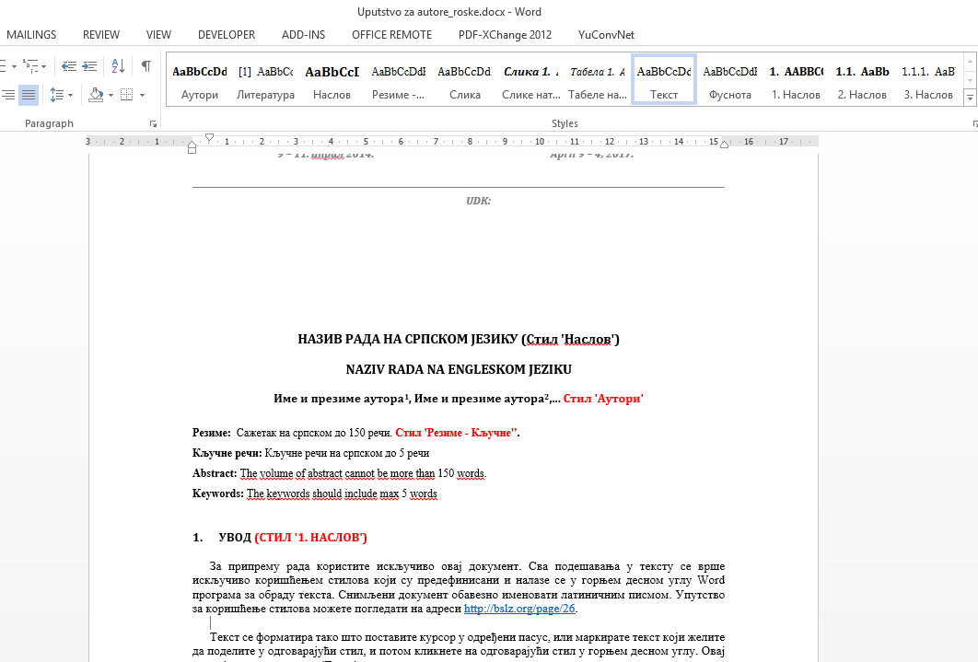
- Location of style settings in Word 2007 and newer versions. 'Figure caption' style.

PICTURES AND TABLES
Figures (diagrams and etc.) and tables should be inside text body at appropriate position (it is not necessary to position figures and tables where you describe them inside text body). For formatting of figures (diagrams and etc.) use 'Figure' style. For figure caption (diagram and etc.) located below figure use 'Figure caption' style, and for table caption located above table use 'Table caption' style.
Photos (in-colour or black and white) should be in good quality level which is appropriate for printing.
Figure and table numeration is automated by using of mentioned styles.

- Number of road accidents in Serbia, 2011. 'Table caption' style.
Year | Fatal road accidents | Road accidents with only material damage
2011 | 3 | 5

Numeric values ('2. Heading' style)
Numeric values used in the text, figures and tables should be written in the following way:
- 1/2 → 0,5 or 1/2 (not 0.5);
- one thousand one hundred thirty three → 1.133 (not 1 133 or 1,133);
Use the units of the SI system.

MATHEMATICAL EQUATIONS
Word Equation Editor should be used for writing of mathematic equations.
Matrices should be written in angle brackets.
Mathematic formulas should be increased by 5 mm from the left margin.

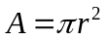 | (1)

Formulas should be numbered with Arabic numbers, in parentheses, using the right alignment. Formulas and numbered should be written in table with no border (as in the given example).
Formulas should be separated from the text with one empty line.

REFERENCES
Footnotes should be used only for additional comments and explanations. Citations in the text should not be marked by footnotes, but should be given at the end of the citation or when making a reference to someone’s work. When citing the authors, their names are written originally, with the year of publication of the work and the page number, in parentheses (Lipovac et al, 2009) or (Lipovac et al, 2009, Lipovac and Nesic, 2005). If more than two authors have been cited, only the first one is named, followed by et al. A comma is used to separate the author from the year of publication, and a semicolon (;) for separating different authors of different works. The number of the page is separated from the year of publication by a colon (:). If the same author has more works published in one year is named, then the subsequent works are marked with alphabet letters attached after the year (for example, 1998a, 1998b, etc.) making sure that they are marked in the bibliography in the same way (the year of publication should be accompanied by a letter mark – 1998a). When citing the source from the Internet, the Internet address and the date when it was downloaded should be cited (http:/www....10.01.2012). When citing law acts, law name should be written in parentheses, followed by article number).
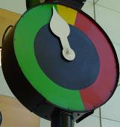
- VMS systems. 'Figure caption' style.

PAPER STRUCTURE
Basically, the research works should contain the following:
- Introduction (Explanation of the problem),
- Material and methods (How we have analysed and solved the problem),
- Results (What we have found out/determined),
- Discussion (What it means),
- Conclusion (A short overview of findings related to the problem defined in the Introduction),
- Acknowledgements (Optional, Thanking for assistance), and
- Bibliography (Works that have been used should be mentioned following this instruction).

BIBLIOGRAPHY
The schedule of references should be made according to the schedule of the family name of the first author (using Latin letter order) and the years of publication. The references should be written in the original letter, using the form given in the example. For references use 'Literature' style, and numeration is automated.

- Elvik, R., Vaa, T. (2004). The Handbook of Road Safety Measures. Elsevier.
- Hauer, E. (1986). On the estimation of the expected number of accidents, Accident Analysis and Prevention, 18 (1), 1-12.
- Липовац, К., и Нешић, М. (2005). Европски акциони програм безбедности саобраћаја - преполовљавање жртава саобраћајних незгода у Европској унији до 2010. године - заједничка одговорност. Безбедност, Београд, 47(3), 513-533.
- Липовац, К., Јованов, Д., и Јовановић, Д. (2009). Савремени приступ унапређењу безбедности пута. Пут и саобраћај, 56(4), 32-37.
- Law on road safety (2009), Official Gazette of the Republic of Serbia, no. 41/09, 53/10, 101/11.

Title (for example PhD, MSc, etc.), name of the author (family name, first name), profession (for example B.Sc. Traffic Eng.), vocation (professor, head of, etc.), institution (name, street and number, city, country), ORCID number, e-mail address – Style 'Footnote'.
Title (for example professor, head of, etc.), name of the author (family name, first name), profession (for example B.Sc. Traffic Eng.), institution (name, street and number, city, country), ORCID number, e-mail address

